Revision History
Date | Version | Description | Author
21/12/25 | 1.1 | Added Static Code Analysis | Özgür Yılmaz,  Alp Eren Erdur
21/12/25 | 1.2 | Added Dependency Analysis | Murad Seyfullayev,  Murat Tuna Özen
22/12/25 | 1.3 | Added Test Coverage Analysis and did a final revision of the document. | Özgür Yılmaz,  Alp Eren Erdur,  Murad Seyfullayev,  Murat Tuna Özen

TABLE OF CONTENTS
Revision History 1
1 Introduction 3
1.1 Document overview 3
2 Static Code Analysis 4
2.1 Tools 4
2.2 Results and Discussion 4
3 Dependency Analysis 5
3.1 Tools 5
3.2 Results and Discussion 5
4 Test Coverage Analysis 6
4.1 Tools 6
4.2 Results and Discussion 6

Introduction

Document overview
This document presents and interprets the code analysis results regarding the HMS software development project. Code is analyzed by 3 different tools: 1) Static Code Analysis tool 2) Dependency Analysis tool and 3) Test Coverage tool. The first tool is used to reveal potential bugs that might be overseen during the testing process. The second tool is employed for evaluating the design quality based on the amount of coupling among the software modules and to what extent the code reflects the originally envisioned design. The last tool is used for measuring the coverage of unit tests in the project. Each section below is dedicated to each of these 3 analysis.

Static Code Analysis

Tools
PMD was selected as the static code analysis tool for this project due to its availability as an integrated plugin in IntelliJ IDEA. PMD is a program that analyzes static source code. It detects programming faults such as unneeded variables, empty catch blocks, and the creation of unnecessary objects, among other things.

Results and Discussion

We used an IntelliJ PMD plugin of the tool, which provided as a GUI like the following:
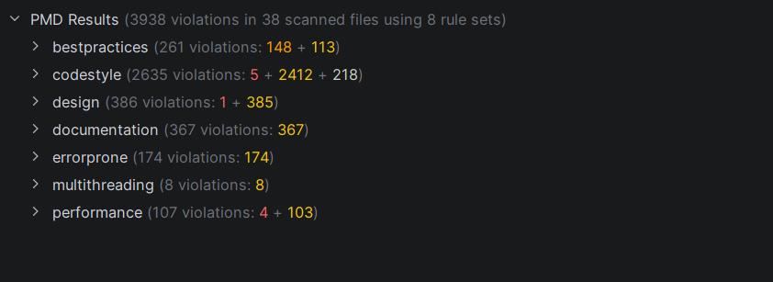

Analysis of alerts that are reported by the tool:

Type | Count of Instances | Severity | Count of Real Bugs
bestpractices | 261 | High | 0
codestyle | 2635 | Medium | 5
design | 386 | Medium | 1
documentation | 367 | Medium | 0
errorprone | 174 | Medium | 0
multithreading | 8 | Medium | 0
performance | 107 | Medium | 4
total | 3938 |  | 10

Dependency Analysis

Tools
We used a Java dependency viewer from IntelliJ IDEA Ultimate. It did not require additional setups or downloads and gave accurate results.

Results and Discussion

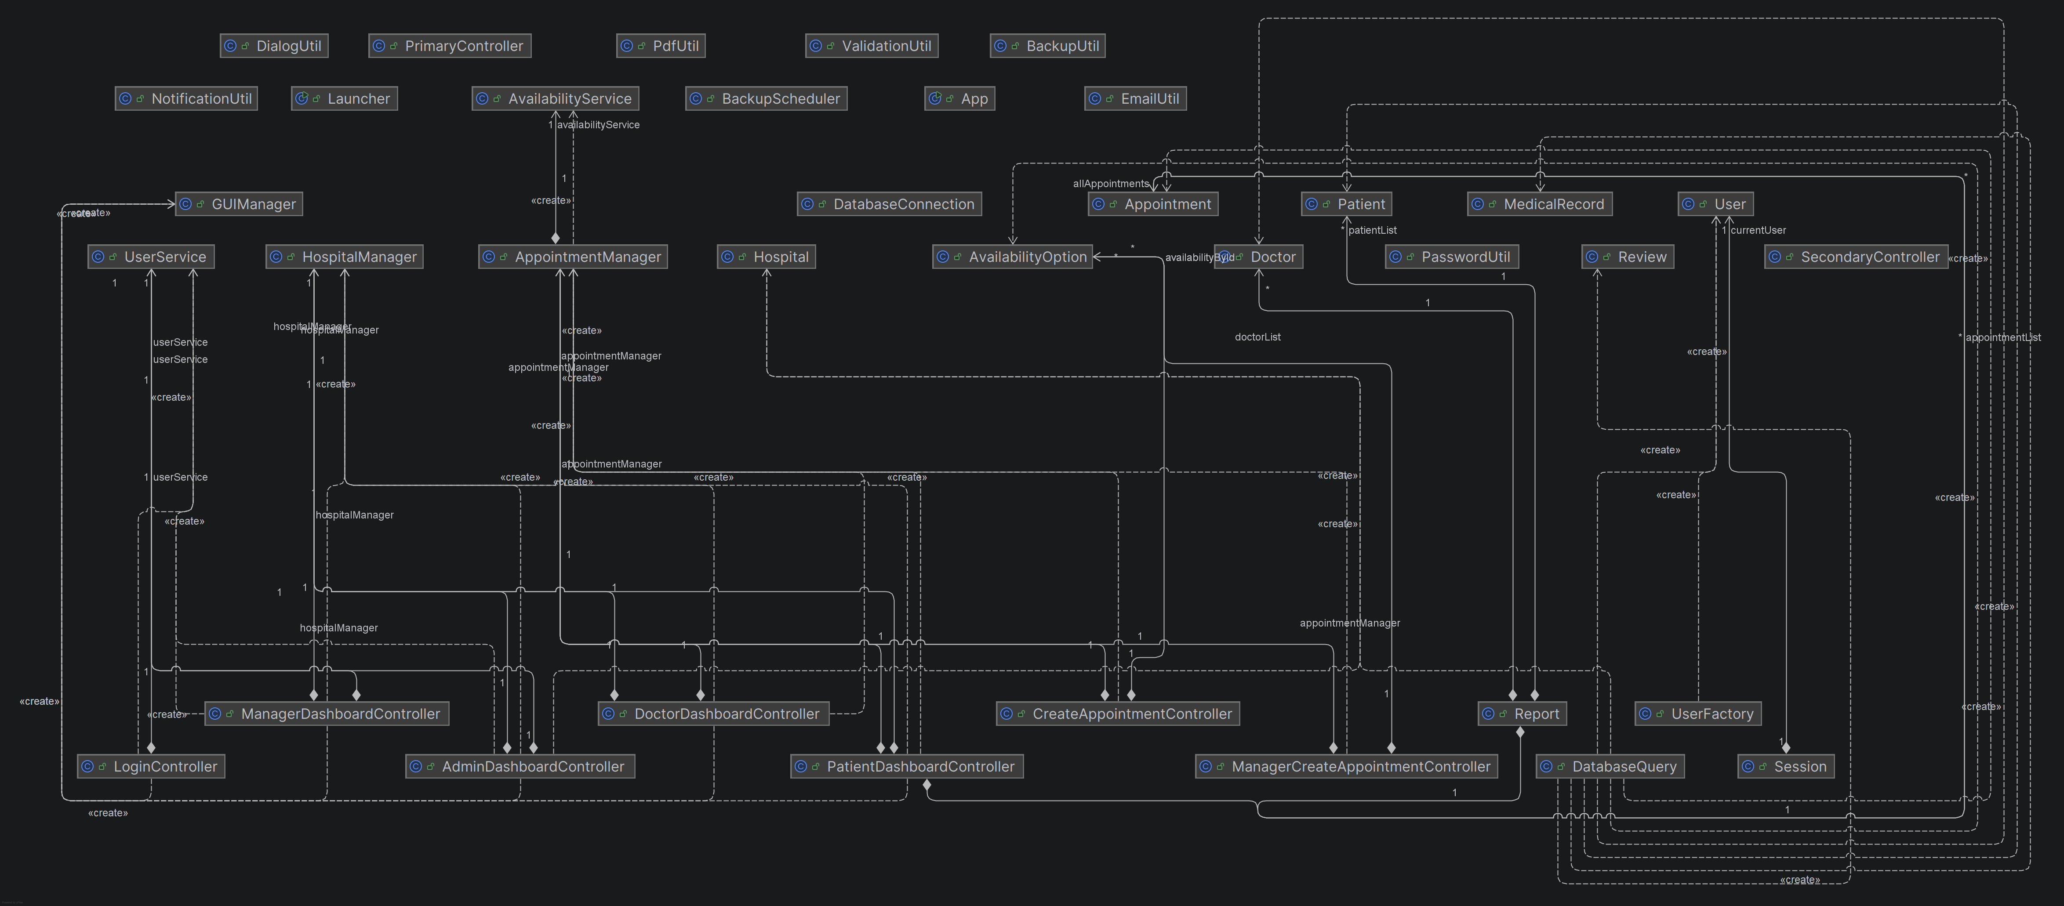

The extracted dependency graph is presented above. We calculated a set of metrics based on this graph as listed below:

# of Edges = 46
# of Nodes = 45
Edge-to-node Ratio = 46 / 45 = 1.02
Tree Impurity = 2 * (46 – 45 + 1) / (45 – 1) * (45 – 2) = 4 / 1892 = 0.002

We have seen that the tree impurity turned out to be quite small. That can be an indication for a good design structure. Edge-to-node ratio is also not very high Another thing is that DatabaseQuery is highly coupled with the other modules. We might consider separating it into several modules to decrease coupling. There are also some nodes which are not connected to any other modules at all. Due to excessive amount of coupling that some modules make and some modules which don’t couple with other modules at all, it sort of neutralizes, which favors the calculation.

Test Coverage Analysis

Tools
We used EclEmma which is built-in with the latest versions of Eclipse to analyze the coverage of our tests

Results and Discussion

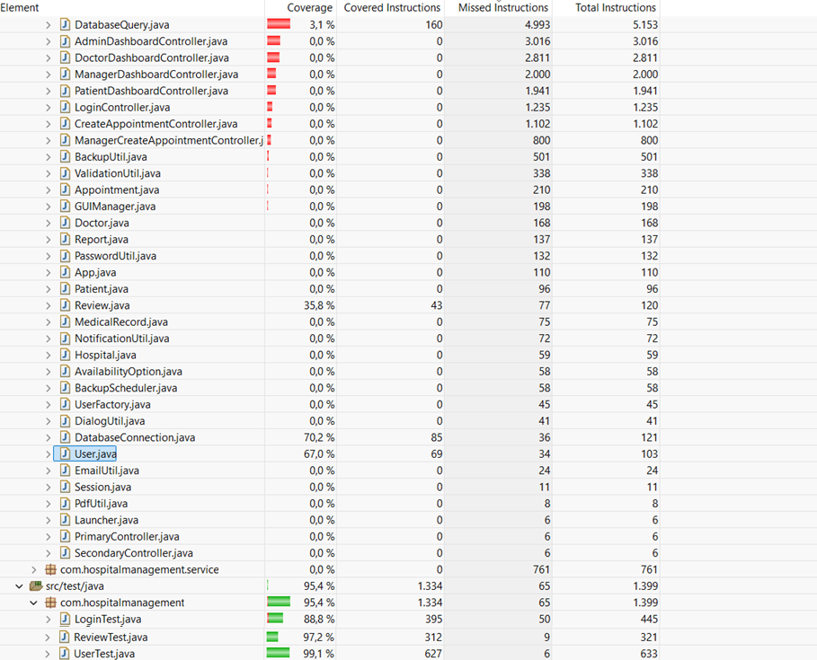

Controller classes do not cover any tests because it is difficult to test GUI components which are handled at the controller classes. User and DatabaseConnection classes has the highest coverage because of the dedicated test classes UserTest and LoginTest. Also some rules regarding Review is also tested. However, the low coverage in DatabaseQuery presents a significant reliability risk. Since this class handles the core CRUD for the system, the lack of tests here means that SQL errors or logic errors could go undetected until runtime.

